Test on Digital Images SOLUTIONS

Exam04 Digital Images
There are several file types used to store images. Most of these file types compress the image; The more often you edit and save, the more degraded the image will be.
Photographs are best saved as JPEG images. To gain a fuller understanding of manipulating images try the following:
Select a digital photograph and try saving the image at different levels of compression. Your aim is to get the best balance between file size and image quality. Compare the file sizes and qualities of each saved image and then answer the following questions.
- At what point in compression does the JPEG become too poor to use on a web page? Is that point the same for all the photos you experimented with? Answers will vary
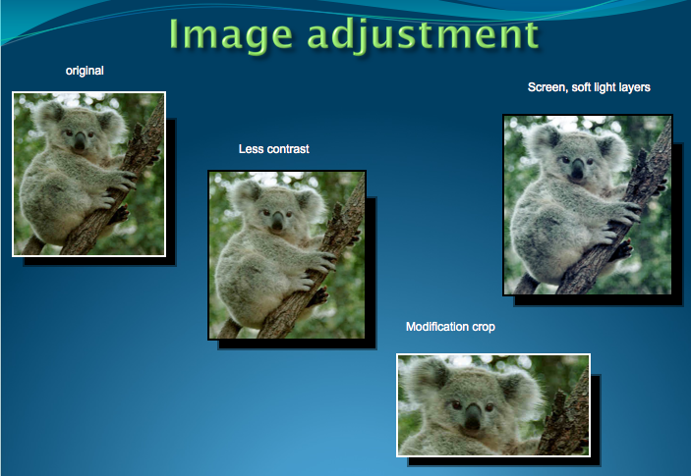

- How do the GIF and JPEG files compare in quality and file size? What conclusions can you draw?

Answers will vary

GIF creates a table of up to 256 colors from a pool of 16 million. If the image has fewer than 256 colors, GIF can render the image exactly. When the image contains many colors, software that creates the GIF uses any of several algorithms to approximate the colors in the image with the limited palette of 256 colors available. Better algorithms search the image to find an optimum set of 256 colors. Sometimes GIF uses the nearest color to represent each pixel, and sometimes it uses "error diffusion" to adjust the color of nearby pixels to correct for the error in each pixel.

GIF achieves compression in two ways. First, it reduces the number of colors of color-rich images, thereby reducing the number of bits needed per pixel, as just described. Second, it replaces commonly occurring patterns (especially large areas of uniform color) with a short abbreviation: instead of storing "white, white, white, white, white," it stores "5 white."

Thus, GIF is "lossless" only for images with 256 colors or less. For a rich, true color image, GIF may "lose" 99.998% of the colors.
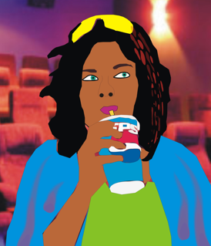

JPG is optimized for photographs and similar continuous tone images that contain many, many colors. It can achieve astounding compression ratios even while maintaining very high image quality. GIF compression is unkind to such images. JPG works by analyzing images and discarding kinds of information that the eye is least likely to notice. It stores information as 24 bit color. Important: the degree of compression of JPG is adjustable. At moderate compression levels of photographic images, it is very difficult for the eye to discern any difference from the original, even at extreme magnification. Compression factors of more than 20 are often quite acceptable. Better graphics programs, such as Paint Shop Pro and Photoshop, allow you to view the image quality and file size as a function of compression level, so that you can conveniently choose the balance between quality and file size.
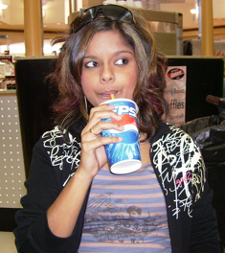
- Create a graph comparing the JPEG file sizes against the different compression levels. Describe the trends. What conclusions can you draw?
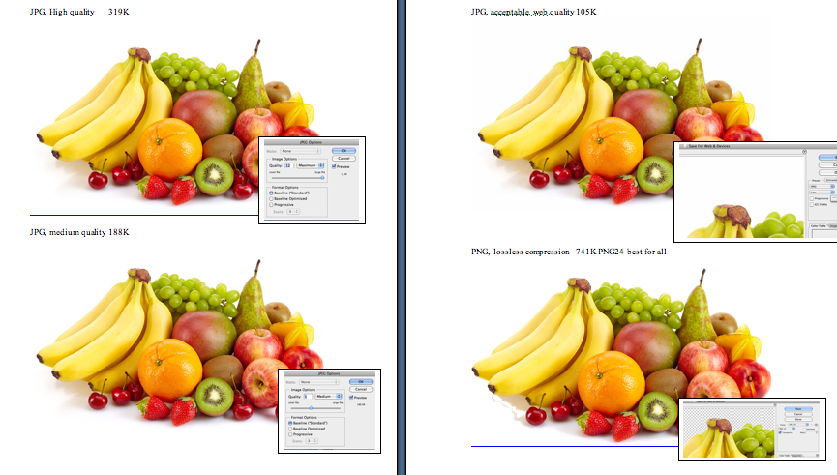
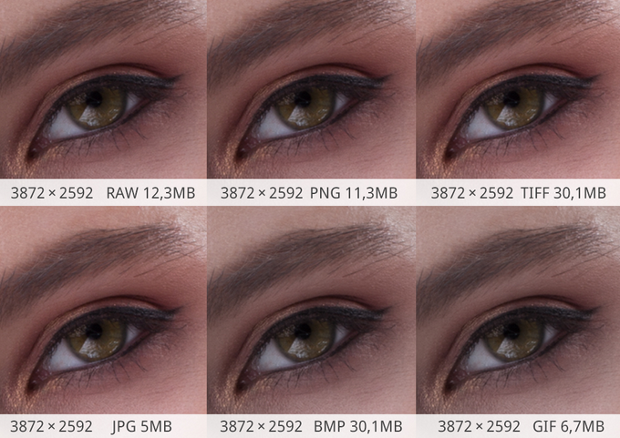
Answers will vary
- Create a table comparing and contrasting the following graphic file formats: BMP, GIF, JPEG and PNG. In your table include information on uses, colour, compression, size, lossy, advantages and disadvantages.
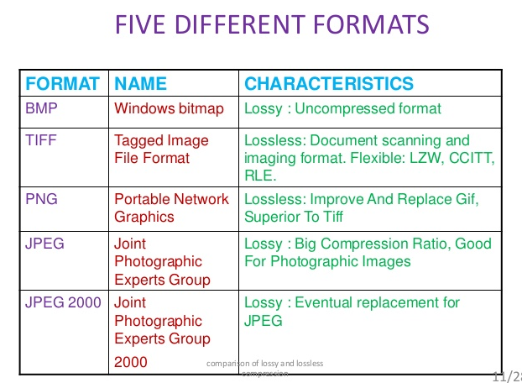
- Answers will vary
Use the internet and reference books to find all the information. The following web sites have some useful information on images.
  - www.wotsit.org .
  - http://graphicsoft.about.com
You need to include some graphics in an electronic presentation on the World Wide Web. The software program you are using only allows the graphic file formats: JPEG, GIF and PNG. The following two graphics of the same resolution are very different. Suggest the most appropriate format to use for each graphic, photo, rabbit and penguin and provide reasons for your choice.

Graphic 1 is Full colour photograph | Graphic 2 is a black and white line diagram
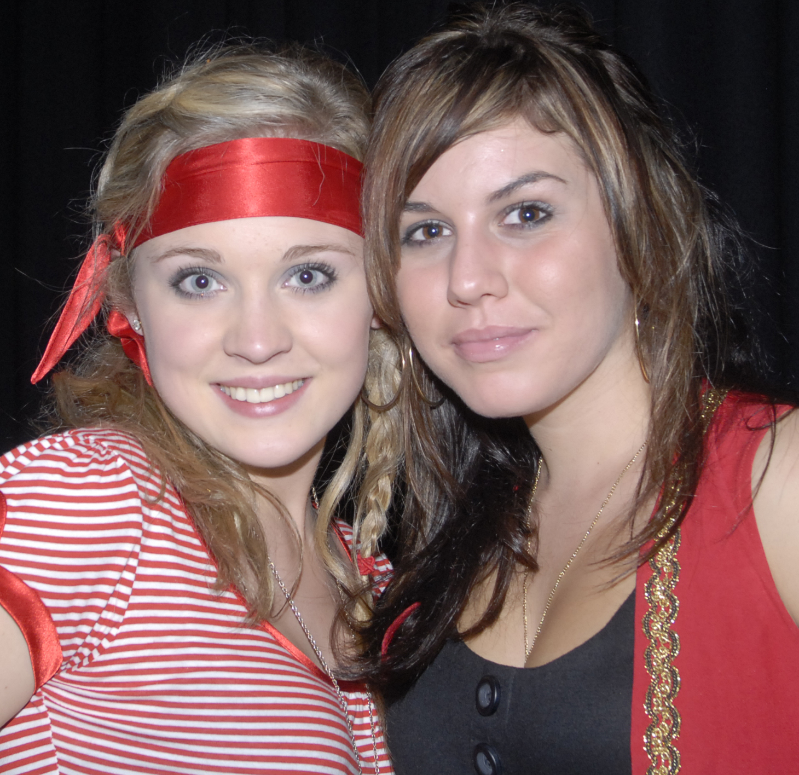 | 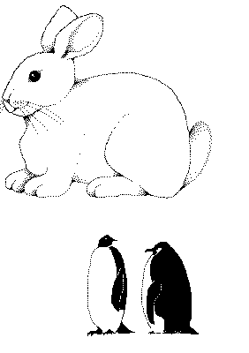

- Graphic 1
  - Format = jpeg, at resolution 72dpi suitable for web
- Reasons = This format supports photos, particularly images with blocks of colour. This format compresses colour better and retains a high degree of colour fidelity. This format has a smaller compression size.
  - Graphic 2 Rabbit
  - Format = pgn with transparent background
  - Reasons = can be used on web page or body can be coloured in or shaded
- Graphic 3 Penguin
  - Format = gif or png as both are suitable for web pages
  - Reasons Image is black and white and the format that best suits this image. GIF supports transparency. In this case, the background is clear. GIF maintains resolution and sharpness, even when compressed, however png 24 is probably the better option for transparency to web.

  - You might like to discuss your answers with your teacher or compare results with fellow students.

Design organisational documents

Activity 1 answers
File Format | BMP  Bitmap | GIF  Graphics Interchange Format | JPEG  Joint Photographic Experts Group | PNG  Portable Network Graphics
Uses | Pattern of pixels or tiny coloured dots. | Web graphics. Ideal for graphics that use only a few colours. Used for bitmap images – line drawings or blocks of a few distinct colours. | Web graphics. Photographs & scanned photos. Images with few distinct colours – illustrations, cartoons, icons & images with blocks of colour. | Web graphics. Single images only.
Colour | Fixed colour palette. | Maximum 256 colour. | True colour 24 bit graphics. Capable of displaying 16.7million colours. | True colour palette and grey scale. 16 million colours.
Compression | Not supported. | Highly compressed – no loss of data. | Smaller than GIF, less compression but better image quality. | 10 – 20% more than a GIF. No loss of data.
Size | Very large. |  | Highest quality – largest file.  Smaller files – reduced quality.
Lossy | No. | Yes – no image quality lost. | Yes. | No.
Advantage | Good for small picture graphics & basic logos. | Can be transparent. Maintains resolution and sharpness even when compresses. Supports animation. | Compresses colour better and retains a high degree of colour fidelity. Can look almost as good as a photo. | Will eventually replace GIF. Platform independent. Greater colour support and better compression. Better support for transparency.
Disadvantage | Large file size. | Loses quality with high resolution pictures. Not effective for detailed photographs. | Not good with straight lines. Smaller file size the more picture info is lost & further away from original. Does not support transparency. | Doesn’t support animation. New format, so only recent browsers can display PNG graphics.

Reference
http://hsc.csu.edu.au/info_tech/compulsory/documents/3553/activity1.htm

